Họ và tên: Lê Trung Sơn

MSSV: 1810482

LAB 3B

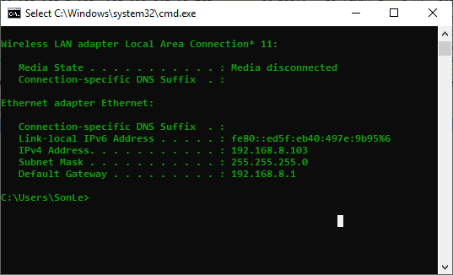

1. What is the IP address and TCP port number used by the client computer (source) that is transferring the file to gaia.cs.umass.edu? To answer this question, it’s probably easiest to select an HTTP message and explore the details of the TCP packet used to carry this HTTP message, using the “details of the selected packet header window” (refer to Figure 2 in the “Getting Started with Wireshark” Lab if you’re uncertain about the Wireshark windows).

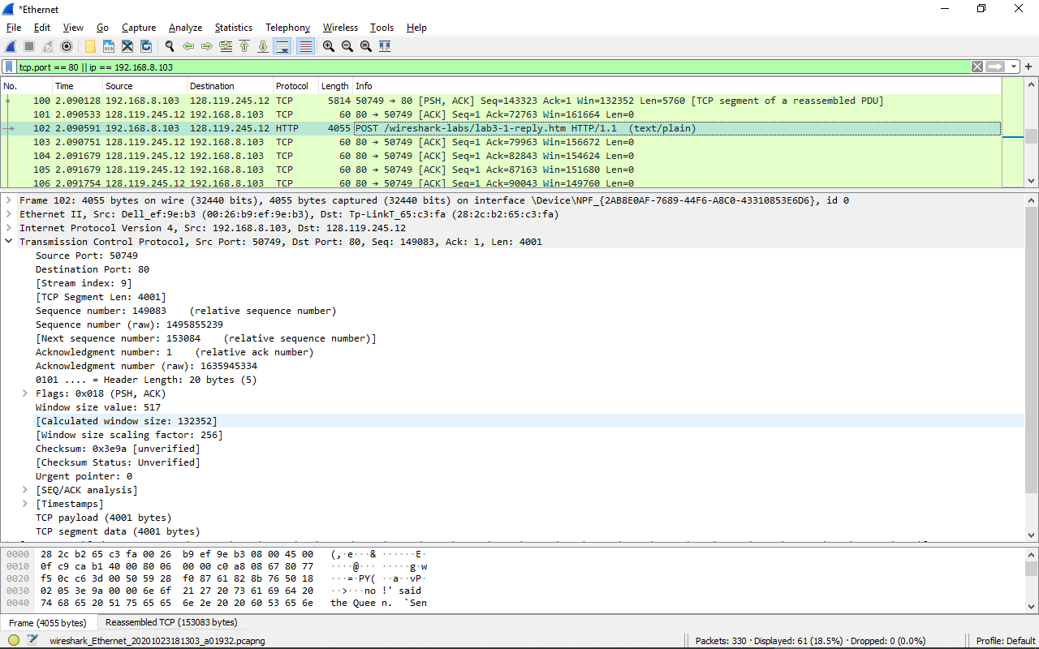

- Client computer (source):

+ IP address là 192.168.8.103

+ TCP Port number là 50749

2. What is the IP address of gaia.cs.umass.edu? On what port number is it sending and receiving TCP segments for this connection?

- Destination computer: gaia.cs.umass.edu

+ IP address là 128.119.245.12

+ TCP Port number là 80

3. What is the IP address and TCP port number used by your client computer (source) to transfer the file to gaia.cs.umass.edu?

- My client computer:

+ IP address là 192.168.8.103

+ TCP Port number là 50749

4. What is the sequence number of the TCP SYN segment that is used to initiate the TCP connection between the client computer and gaia.cs.umass.edu? What is it in the segment that identifies the segment as a SYN segment?

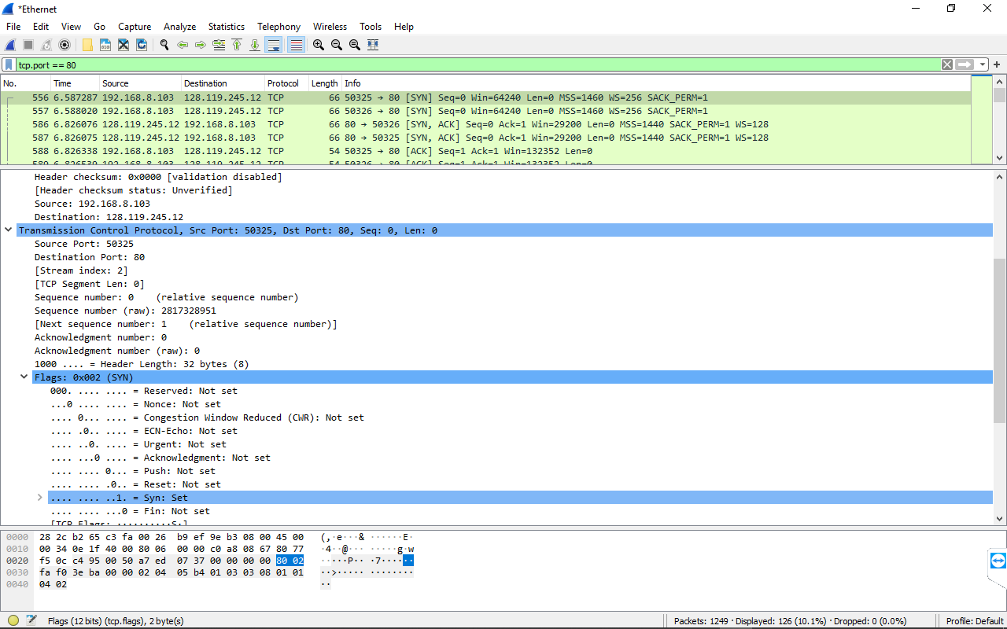

- Sequence number of the TCP SYN segment là 0. Trong message flags có Syn flag được đặt là 1 để chỉ ra rằng đó là 1 SYN segment

5. What is the sequence number of the SYNACK segment sent by gaia.cs.umass.edu to the client computer in reply to the SYN? What is the value of the Acknowledgement field in the SYNACK segment? How did gaia.cs.umass.edu determine that value? What is it in the segment that identifies the segment as a SYNACK segment?

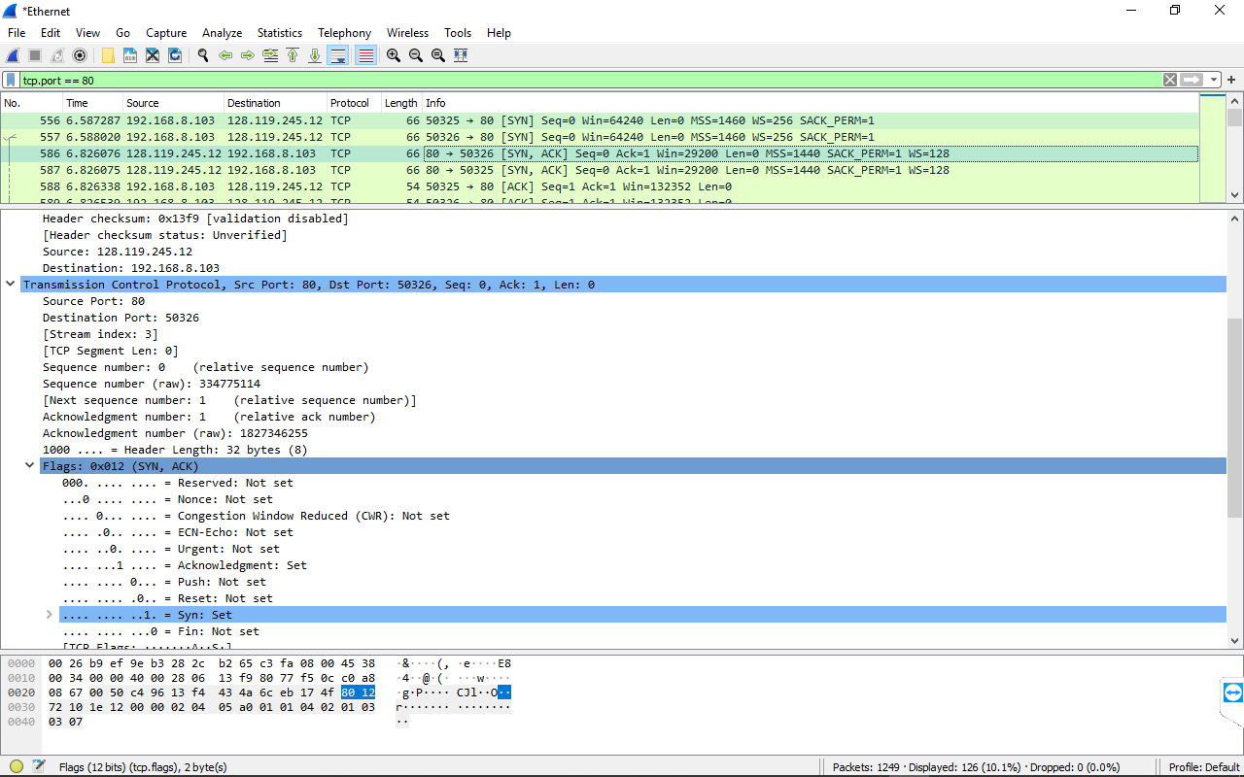

- Sequence number of the SYNACK segment là 0

- Giá trị của trường Acknowledgement trong SYNACK segment là 1

- Xác định giá trị này bằng cách cộng thêm 1 vào giá trị của Sequence number of the TCP SYN segment ban đầu là 0

- Trong message flags có Syn flag và Acknowledgement flags đều được đặt là 1 để chỉ ra rằng đó là 1 SYNACK segment

6. What is the sequence number of the TCP segment containing the HTTP POST command? Note that in order to find the POST command, you’ll need to dig into the packet content field at the bottom of the Wireshark window, looking for a segment with a “POST” within its DATA field.

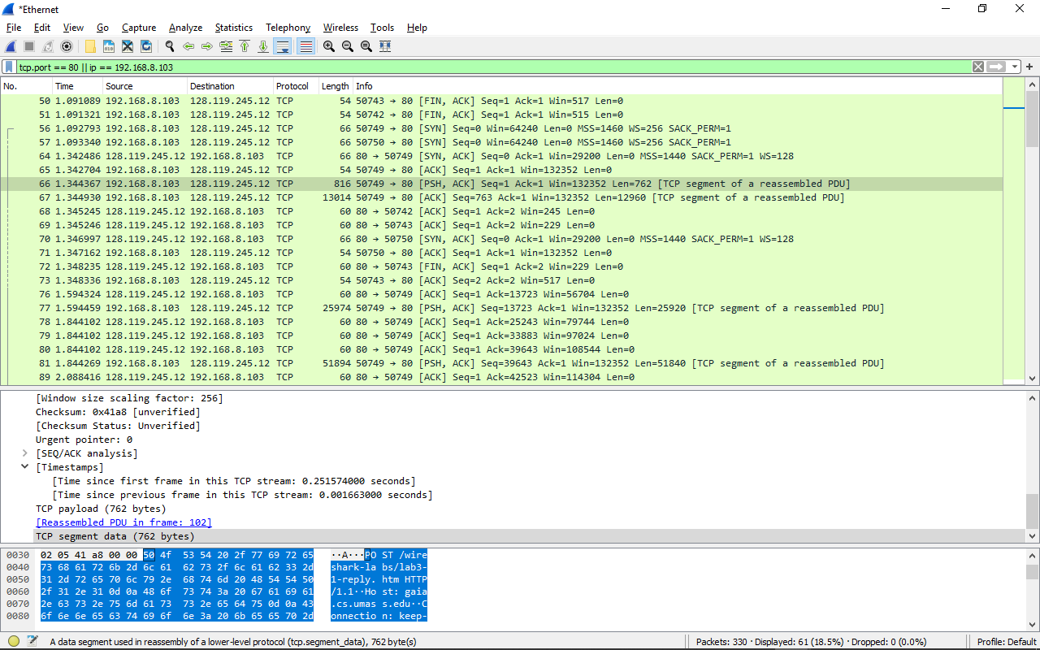

- Sequence number of the TCP segment containing the HTTP POST command là 1, segment số 66

7. Consider the TCP segment containing the HTTP POST as the first segment in the TCP connection. What are the sequence numbers of the first six segments in the TCP connection (including the segment containing the HTTP POST)? At what time was each segment sent? When was the ACK for each segment received? Given the difference between when each TCP segment was sent, and when its acknowledgement was received, what is the RTT value for each of the six segments? What is the EstimatedRTT value (see Section 3.5.3, page 242 in text) after the receipt of each ACK? Assume that the value of the EstimatedRTT is equal to the measured RTT for the first segment, and then is computed using the EstimatedRTT equation on page 242 for all subsequent segments.

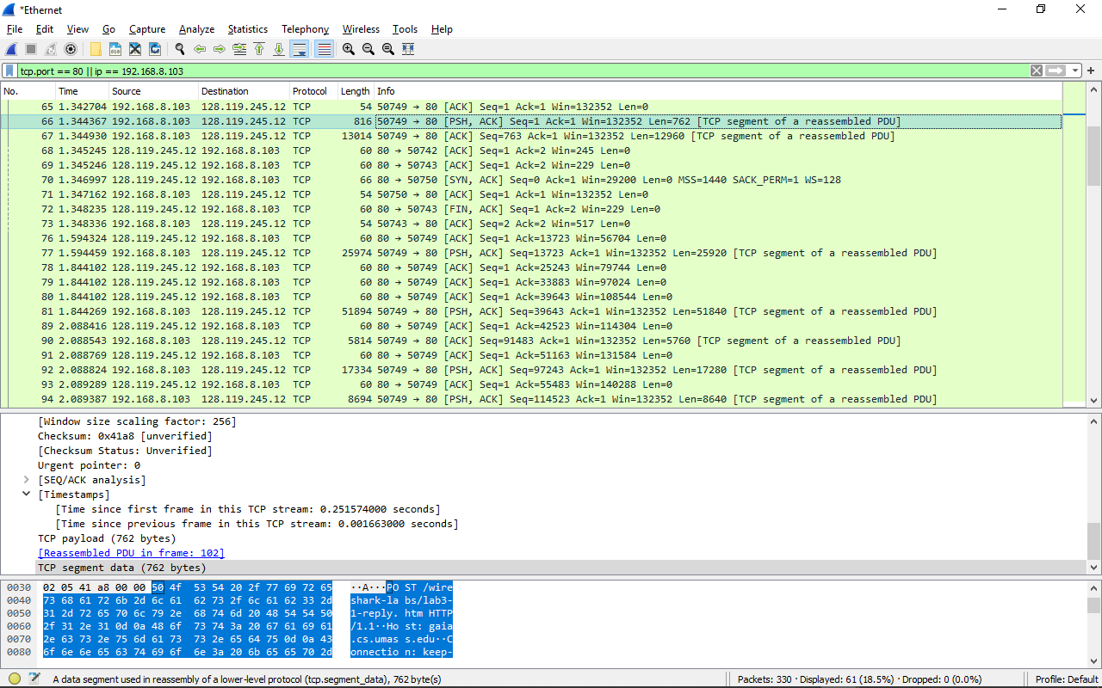- Số thứ tự của sáu phân đoạn đầu tiên trong kết nối TCP (bao gồm cả phân đoạn chứa HTTP POST) là 66, 67, 77, 80, 90, 92

- Mỗi đoạn được gửi vào thời gian là

+ 66 sequence numbers là 1

+ 67 sequence numbers là 763

+ 77 sequence numbers là 13723

+ 81 sequence numbers là 39643

+ 90 sequence numbers là 91483

+ 92 sequence numbers là 97243

- Số thứ tự của sáu ACK là 76, 78, 79, 80, 89, 91

- Dùng công thức sau EstimatedRTT = 0.875 * EstimatedRTT + 0.125 * SampleRTT

|  |  |  |  |  |
| --- | --- | --- | --- | --- |
|  | sent time | ACK recived time | RTT | EstimatedRTT |
| segment 1 | 1,3443670 | 1,3469970 | 0,0026300 | 0,0026300 |
| segment 2 | 1,3449300 | 1,5943240 | 0,2493940 | 0,0334755 |
| segment 3 | 1,5944590 | 1,8441020 | 0,2496430 | 0,2494251 |
| segment 4 | 1,8442690 | 2,0884160 | 0,2441470 | 0,2489560 |
| segment 5 | 2,0885430 | 2,0887690 | 0,0002260 | 0,2136569 |
| segment 6 | 2,0888240 | 2,0892890 | 0,0004650 | 0,0002559 |

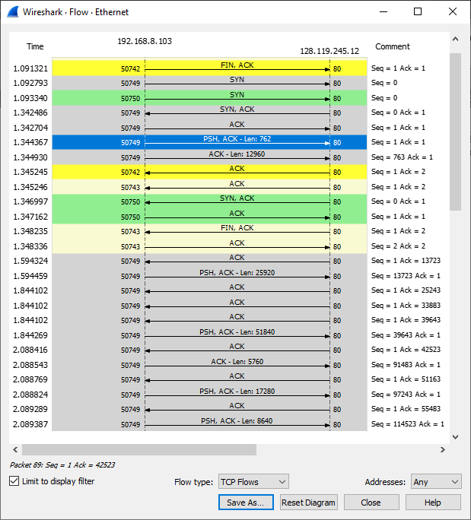

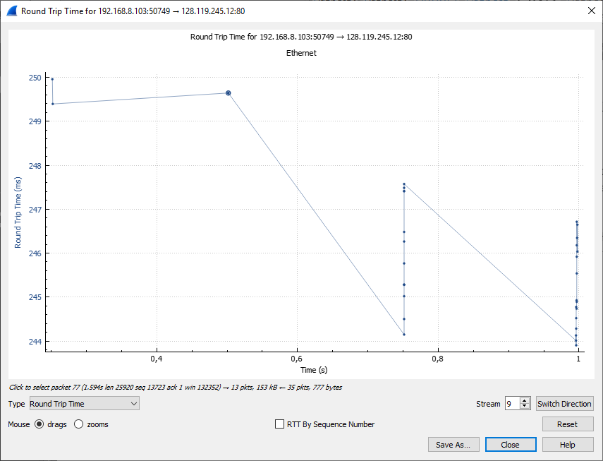

8. What is the length of each of the first six TCP segments?

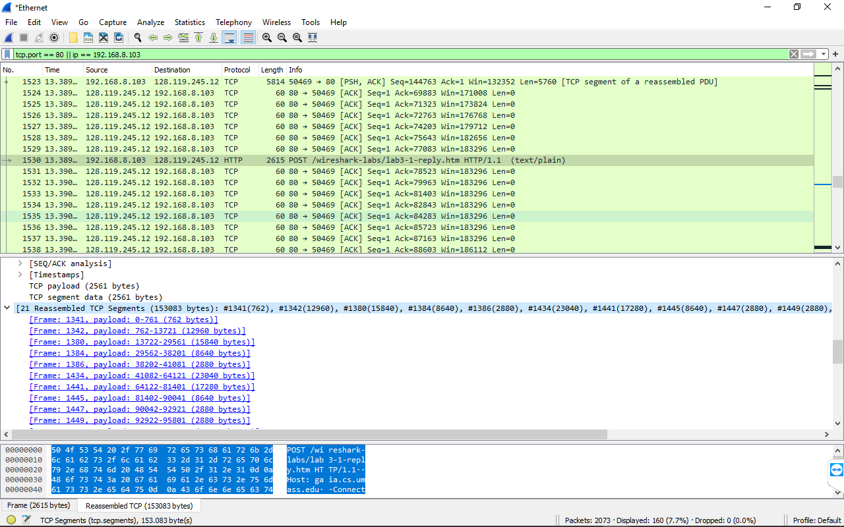

- Độ dài của TCP segment đầu tiên là 762 bytes

- Độ dài của TCP segment thứ hai là 12960 bytes

- Độ dài của TCP segment thứ ba là 15840 bytes

- Độ dài của TCP segment thứ tư là 8640 bytes

- Độ dài của TCP segment thứ năm là 2880 bytes

- Độ dài của TCP segment thứ sáu là 23040 bytes

9. What is the minimum amount of available buffer space advertised at the received for the entire trace? Does the lack of receiver buffer space ever throttle the sender?

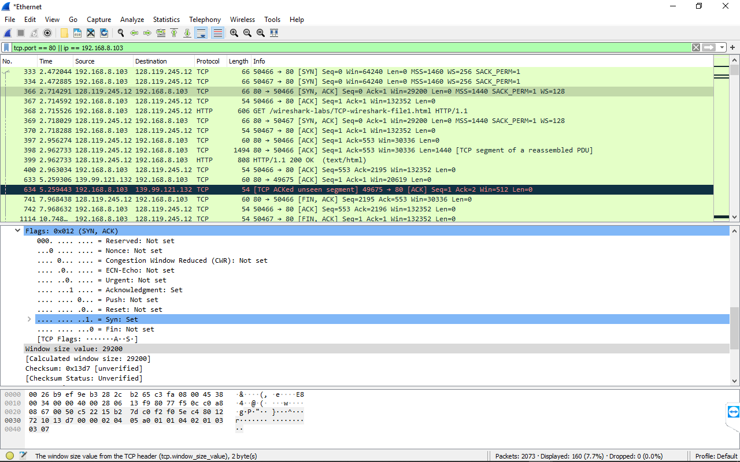

- Minimum amount of available buffer space là 29200

- Người gửi không bao giờ bị giới hạn tốc độ bởi maximum của receiver buffer size of 62780 bytes và sẽ kiểm tra dấu vết

10. Are there any retransmitted segments in the trace file? What did you check for (in the trace) in order to answer this question?

- Không có segments nào được truyền lại. Ta có thể kiểm tra bằng cách Acknowledgement cũ không bao giờ được gửi lại để gọi lại các gói tin cũ.

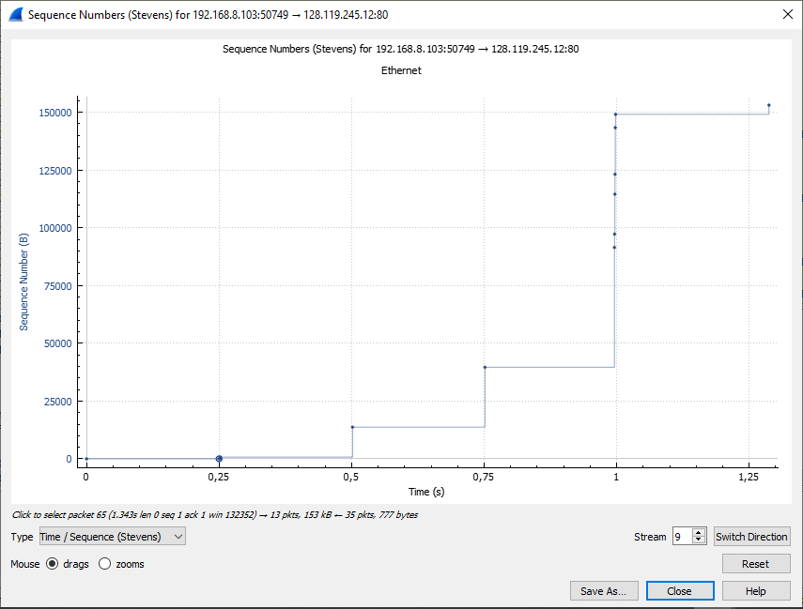

11. How much data does the receiver typically acknowledge in an ACK? Can you identify cases where the receiver is ACKing every other received segment (see Table 3.2 on page 250 in the text).

- Dữ liệu thường nhận được trong 1 ACK là 1440 bytes.

- Trường hợp mà receiver is ACKing every other received segment là segment số 108

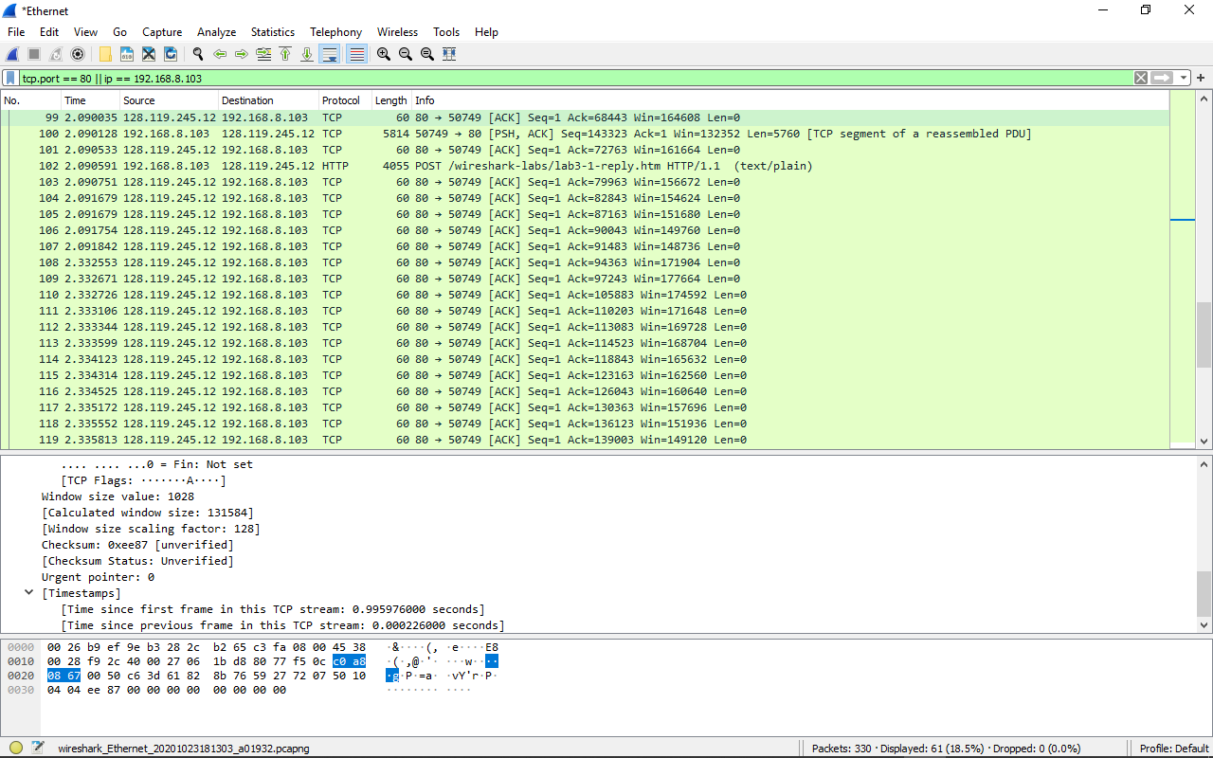

12. What is the throughput (bytes transferred per unit time) for the TCP connection? Explain how you calculated this value.

- Ta lấy ACK cuối cùng trừ đi TCP segment đầu tiên chia cho tổng thời gian giữa 2 cái đó

Throughput = (153084-1)/(2.337238-1.344367)=154182.1647 bytes/s

13. Use the Time-Sequence-Graph(Stevens) plotting tool to view the sequence number versus time plot of segments being sent from the client to the gaia.cs.umass.edu server. Can you identify where TCP’s slowstart phase begins and ends, and where congestion avoidance takes over? Comment on ways in which the measured data differs from the idealized behavior of TCP that we’ve studied in the text

- Slowstart phase bắt đầu từ giây 0 đến giây 0.75. sau đó congestion avoidance diễn ra

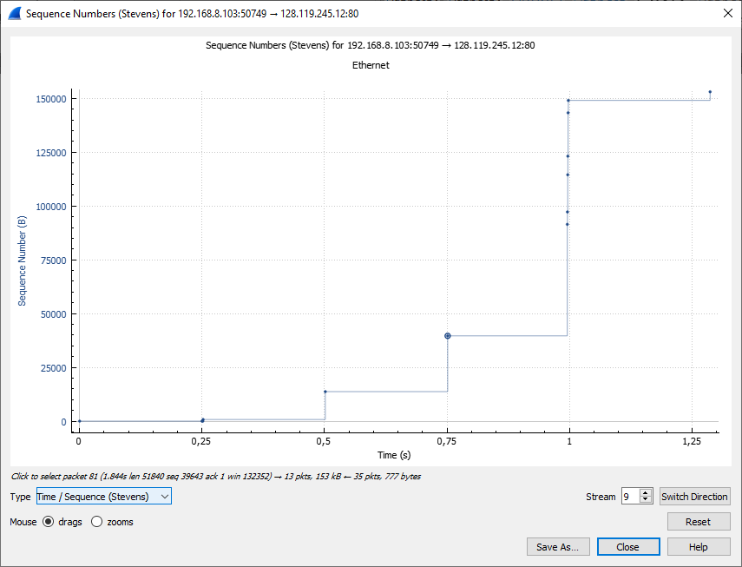

14. Answer each of two questions above for the trace that you have gathered when you transferred a file from your computer to gaia.cs.umass.edu

- Đã trả lời